**Bootstrap3 Landing Page for Dental Care Site With Sticky Header and Modal:**

**Header and Carousel: Desktop View**

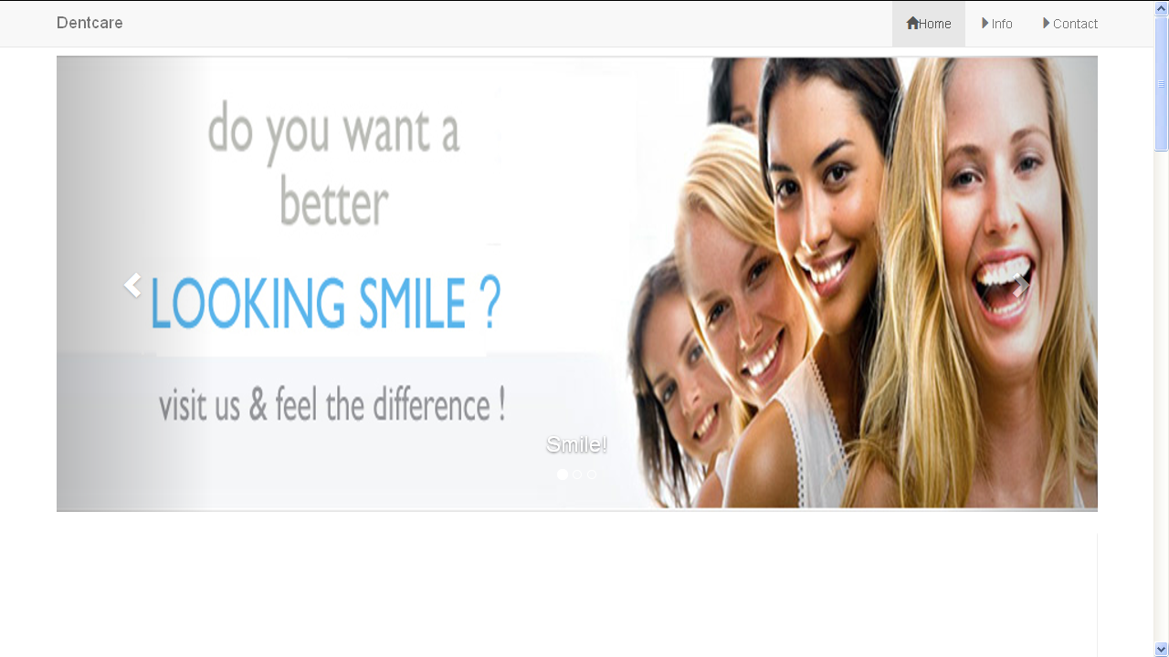

**Panels:**

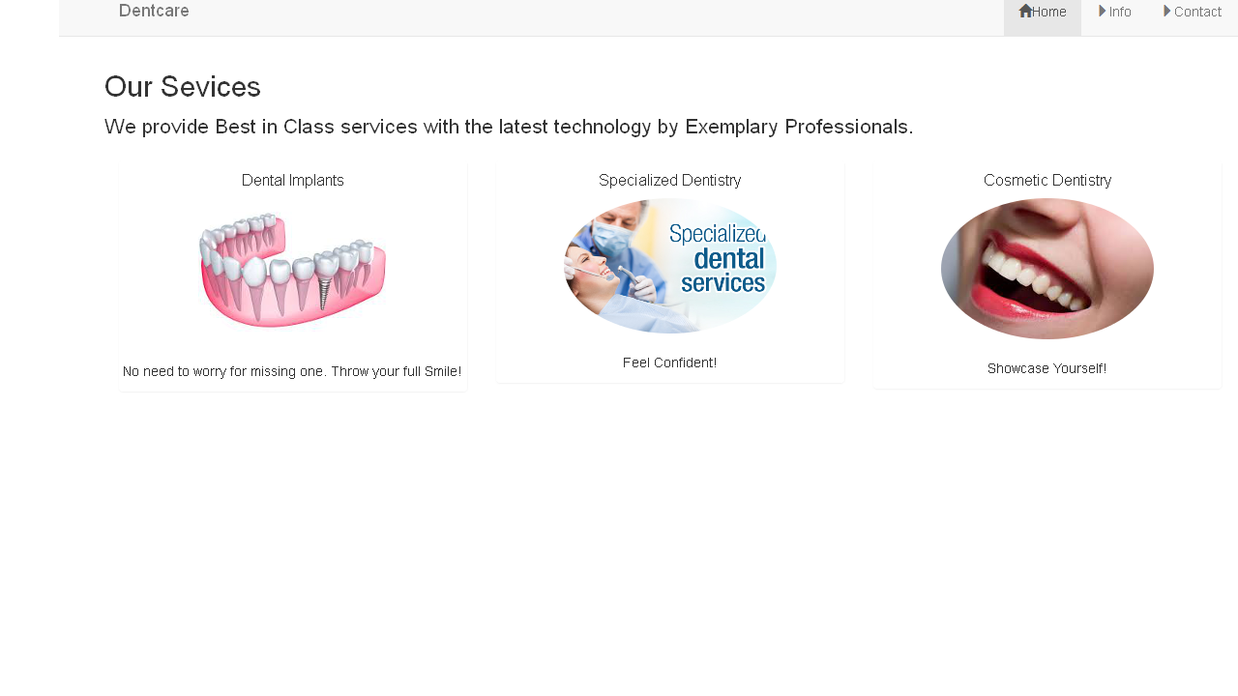

**Other Features:**

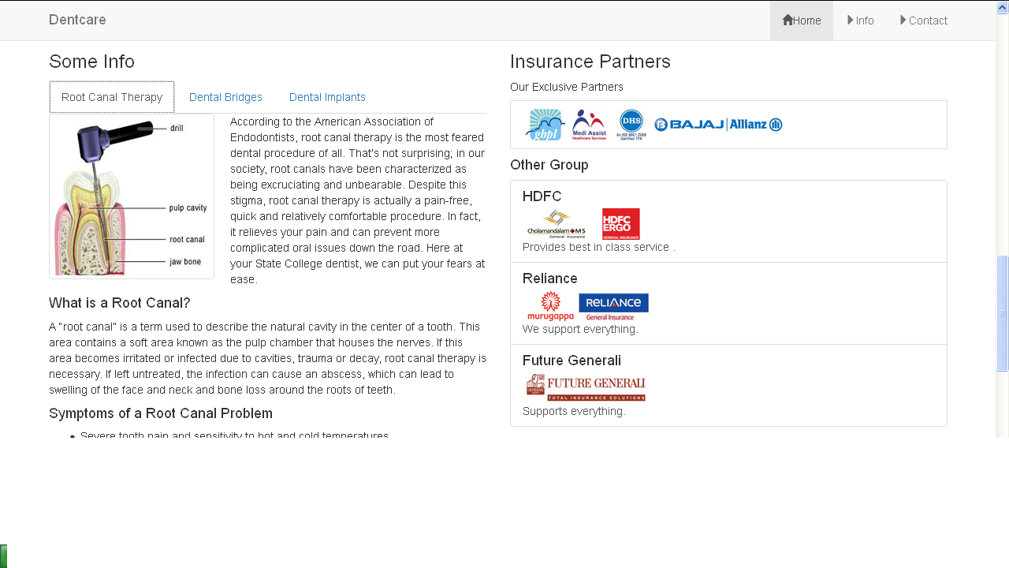

**Modal:**

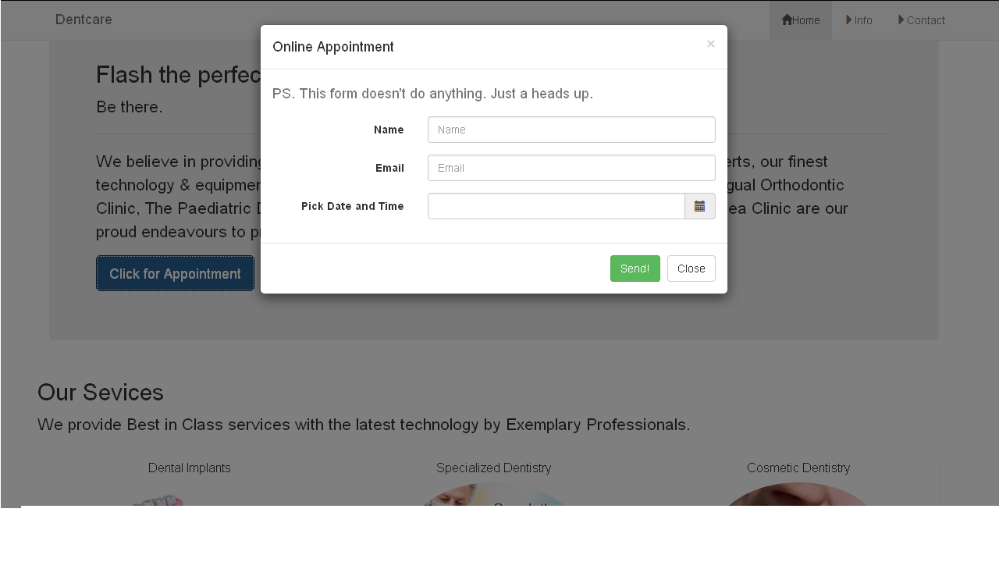

**Tablet View: A)**

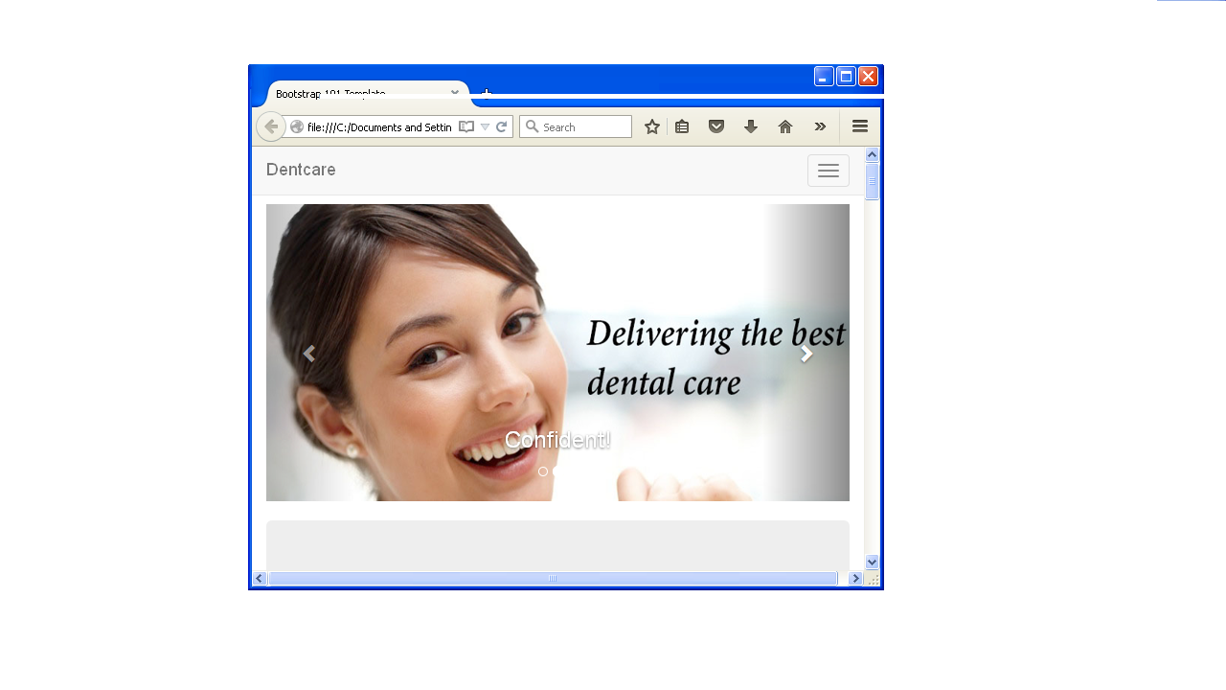

**B)**

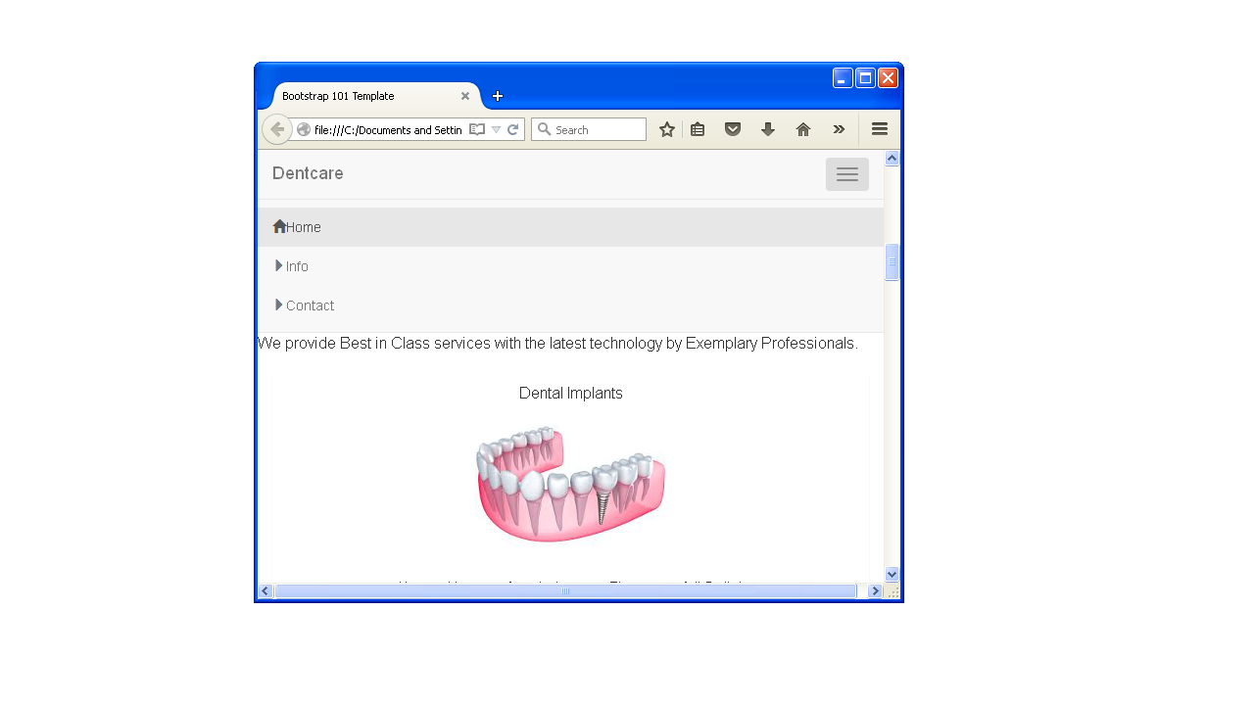

**Mobile View : 1)**

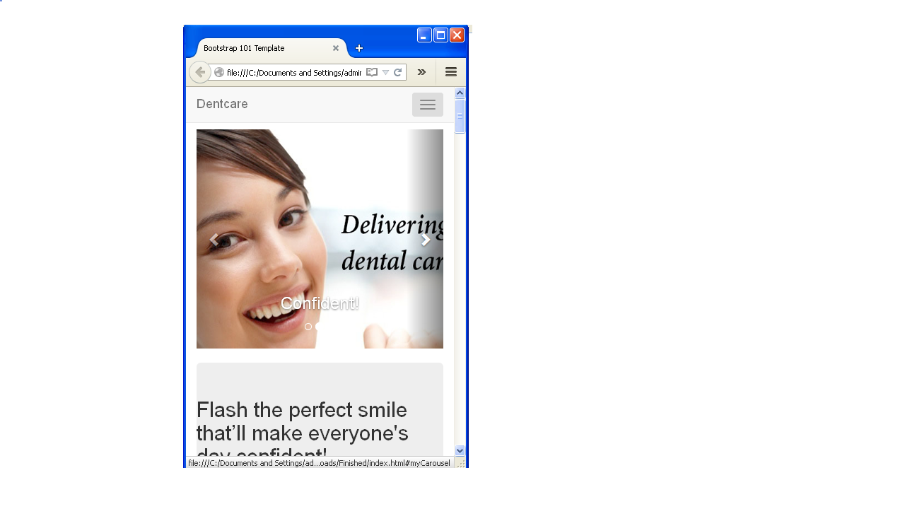

**2)**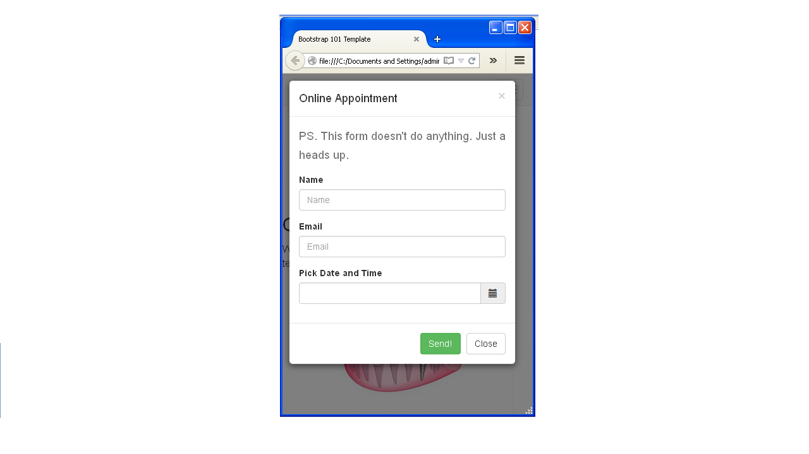

**It includes moments.js for Date and Time picking .**